**NAME – SITANSHU SEKHAR PANDA**

**SCREENSHOTS----**

AWS LOGIN SCREEN

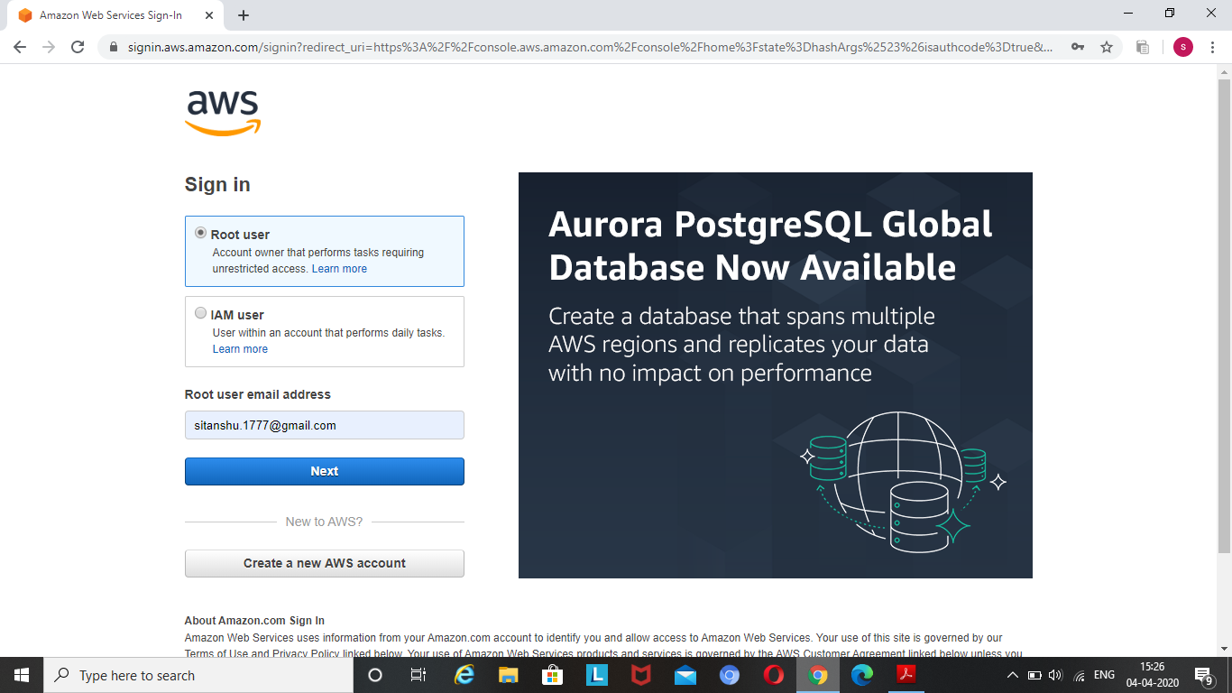

EC2 DASHBOARD

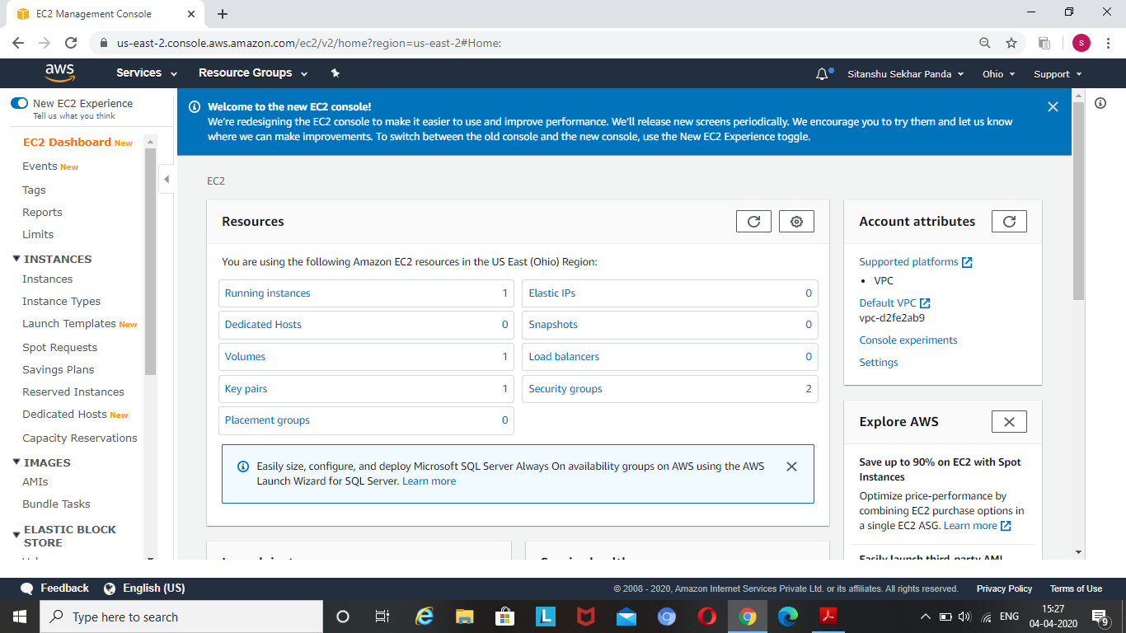

S3 DASHBOARD

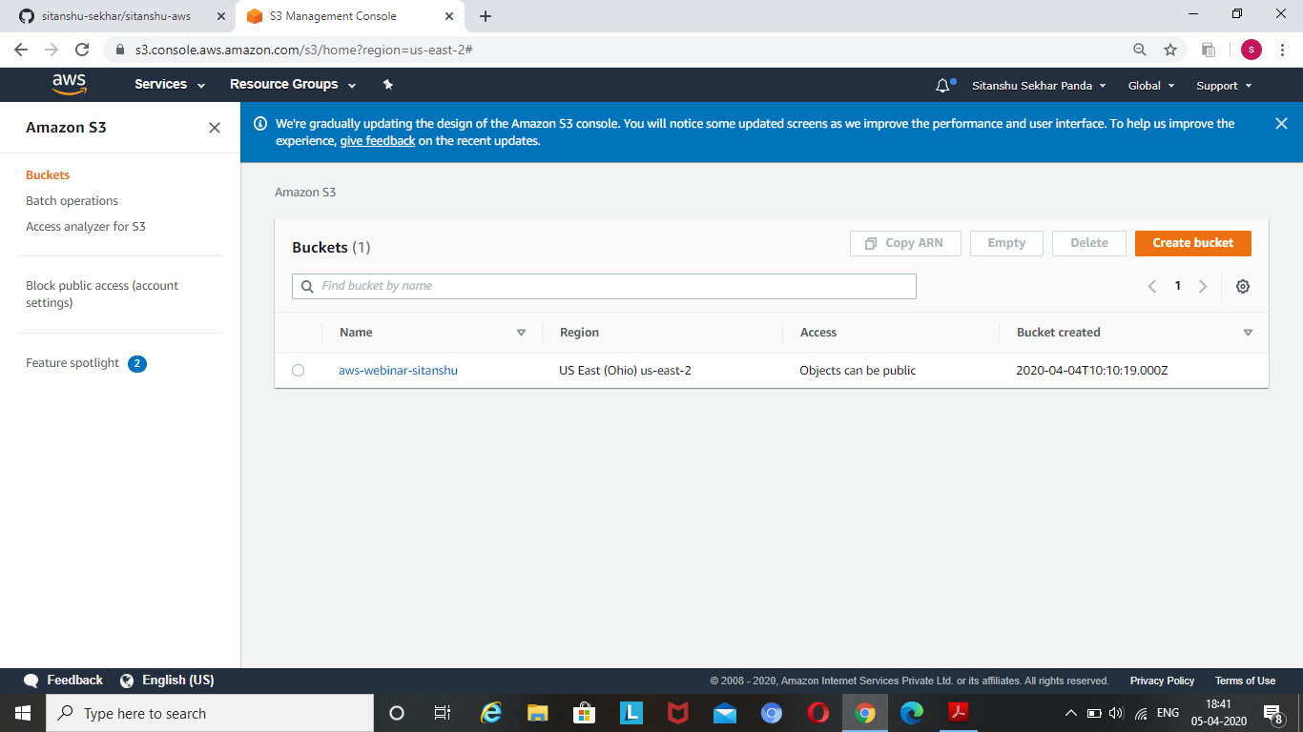

REKOGNITION DASHBOARD

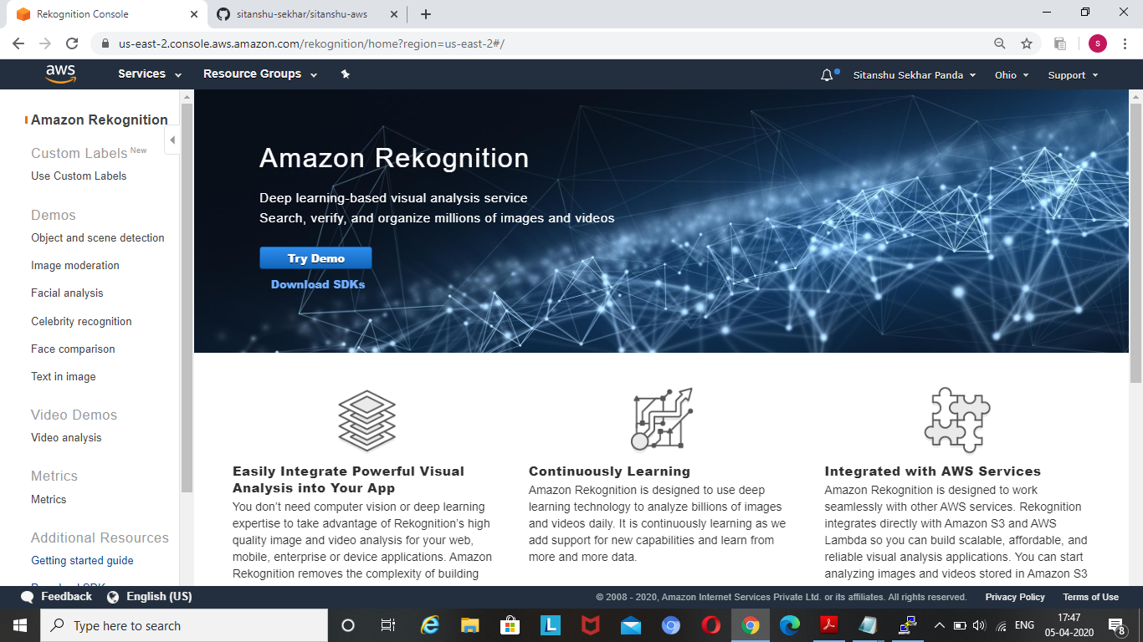

CHOOSING AN AMI

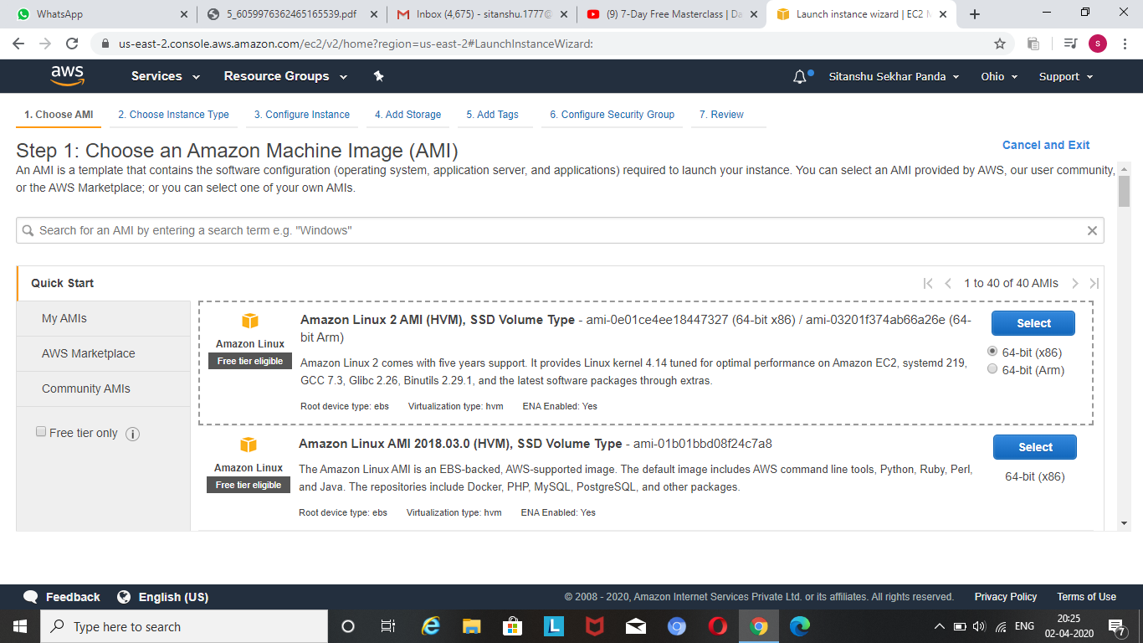

CHOOSING AN INSTANCE

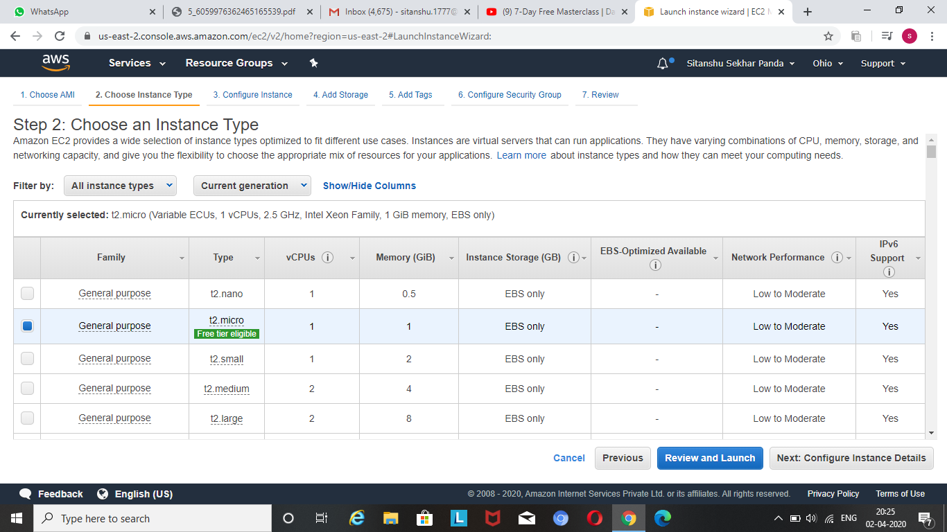

ADDING STORAGE

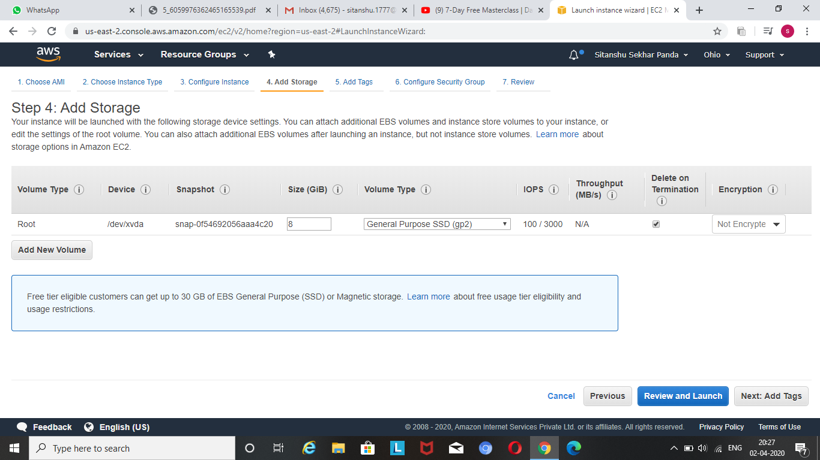

CONFIGURING SECURITY GROUP

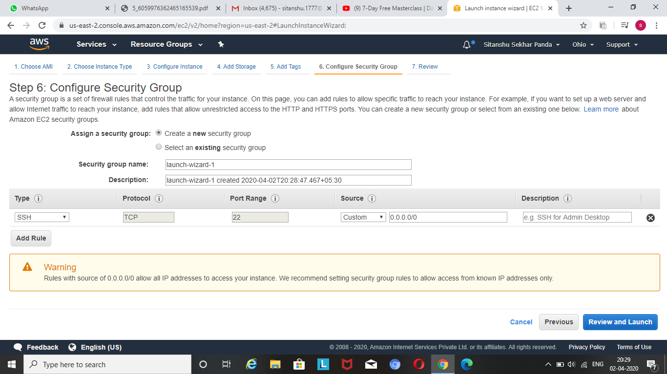

KEY PAIR DOWNLOAD

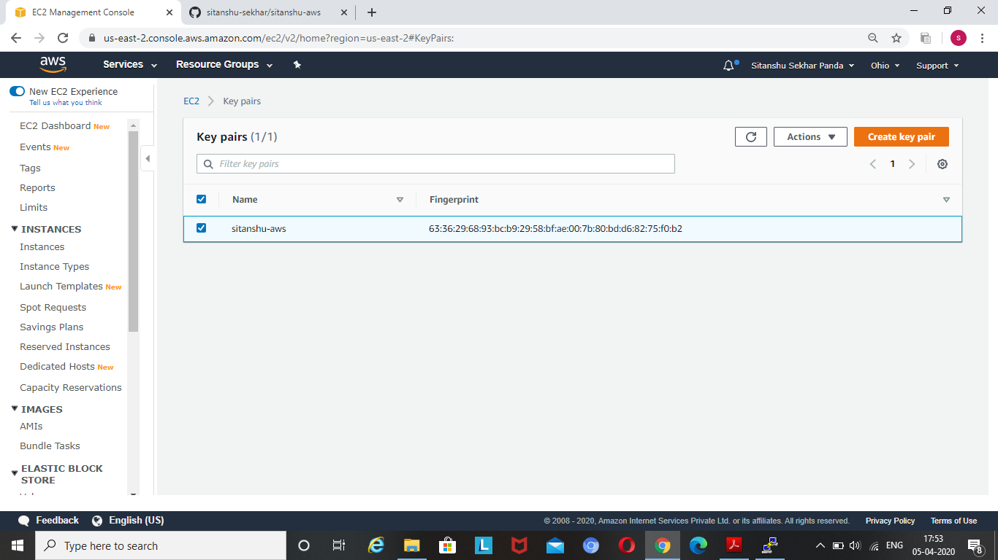

PUTTYGEN CONVERSION FROM PEM TO PPK

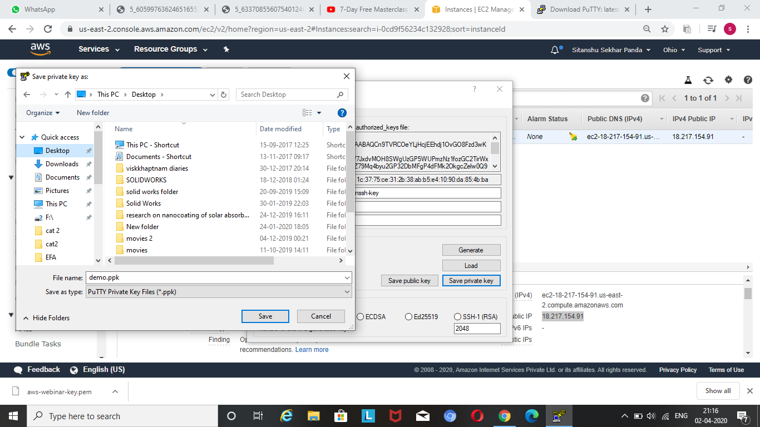

LOGGED IN EC2 BLACK SCREEN

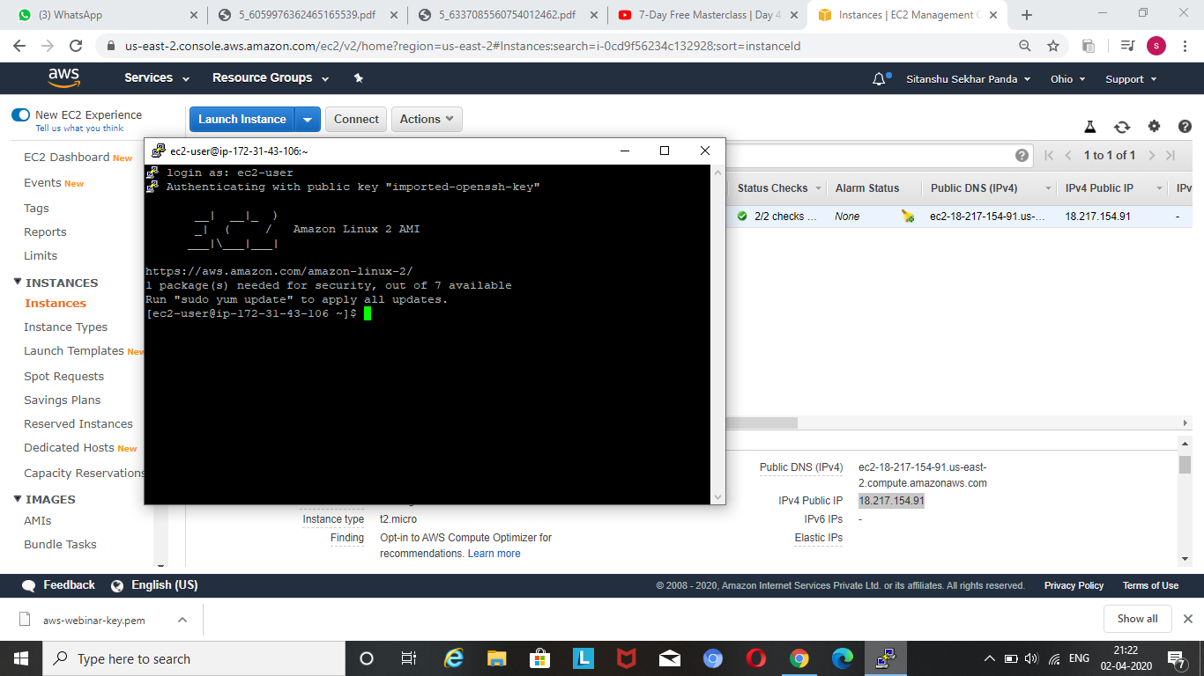

CREATING A BUCKET

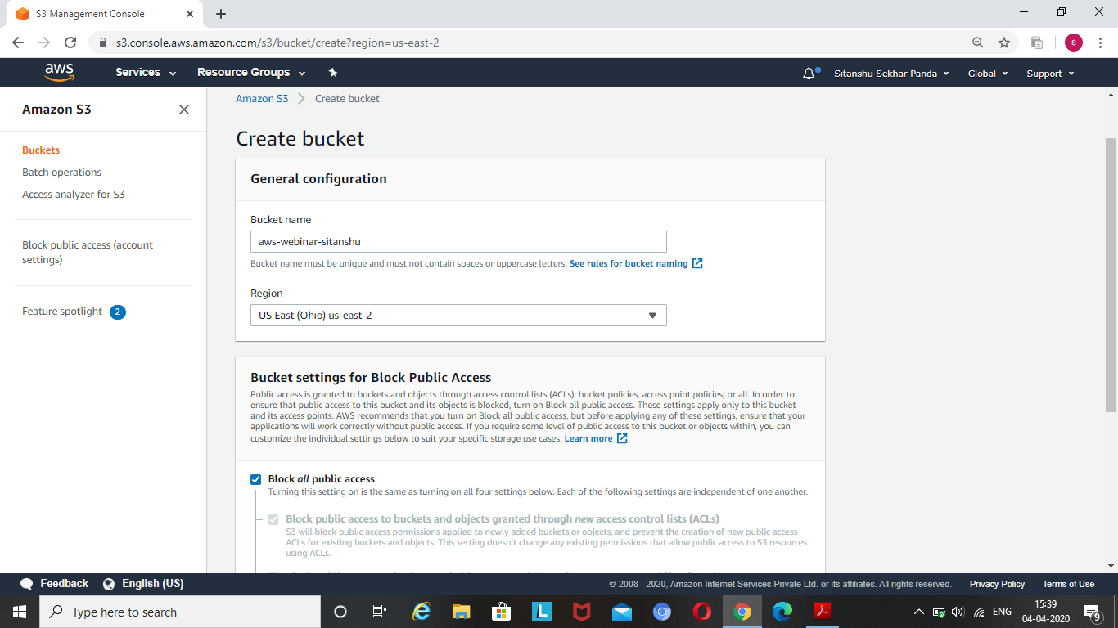

UPLOADING AN OBJECT

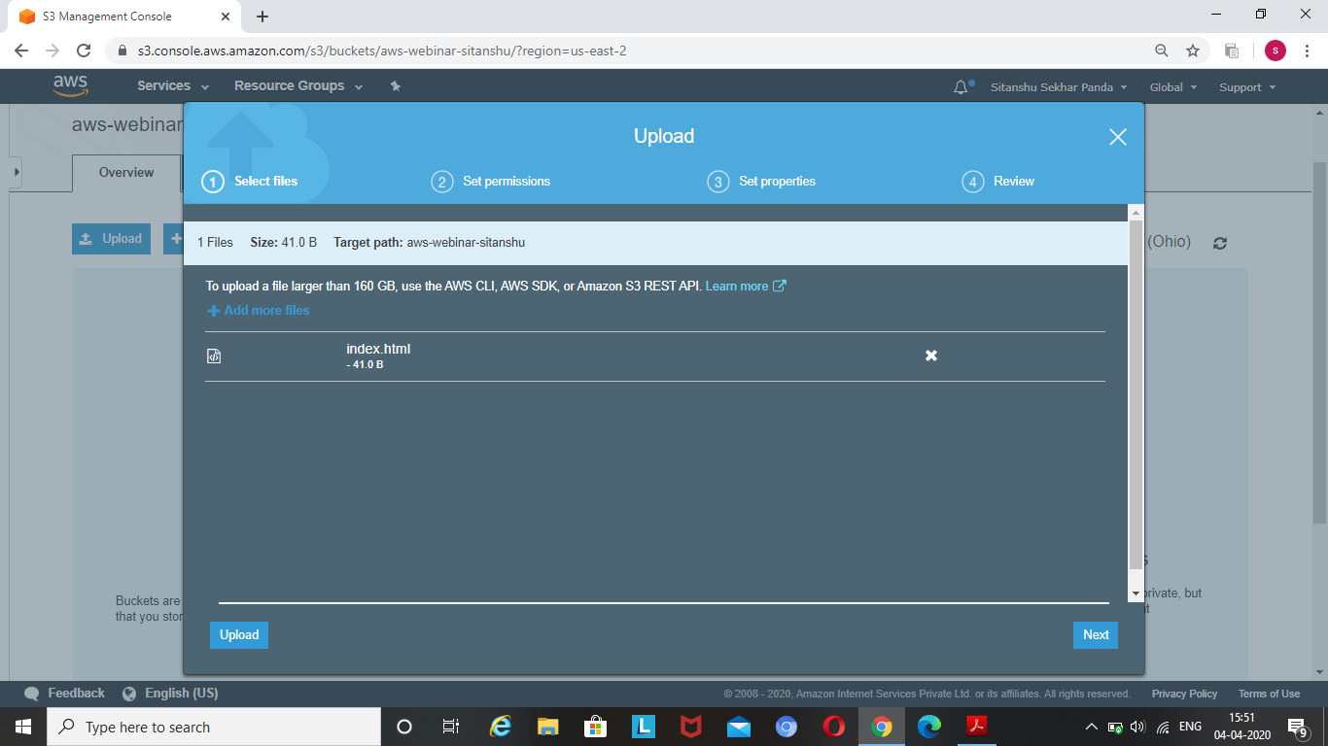

ENABLING STATIC WEBSITE

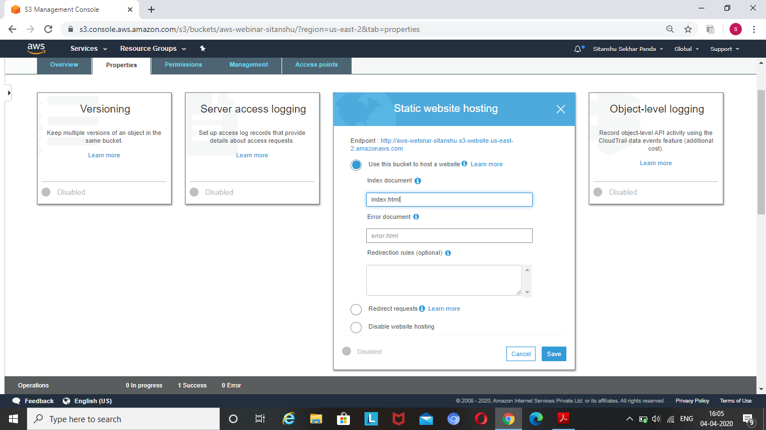

MAKING OBJECT PUBLIC

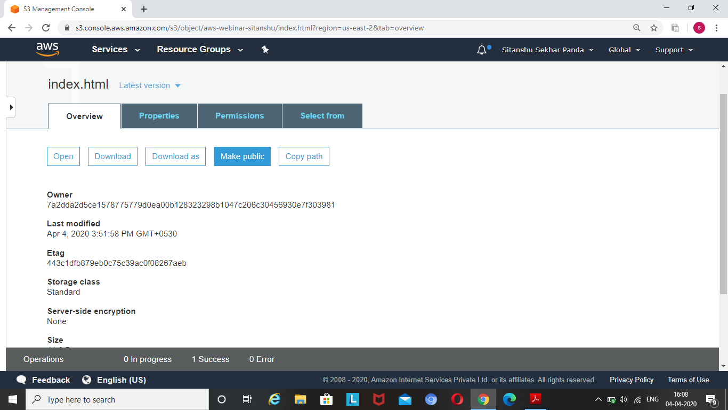

CHECKING THE S3 LINK ON BROWSER

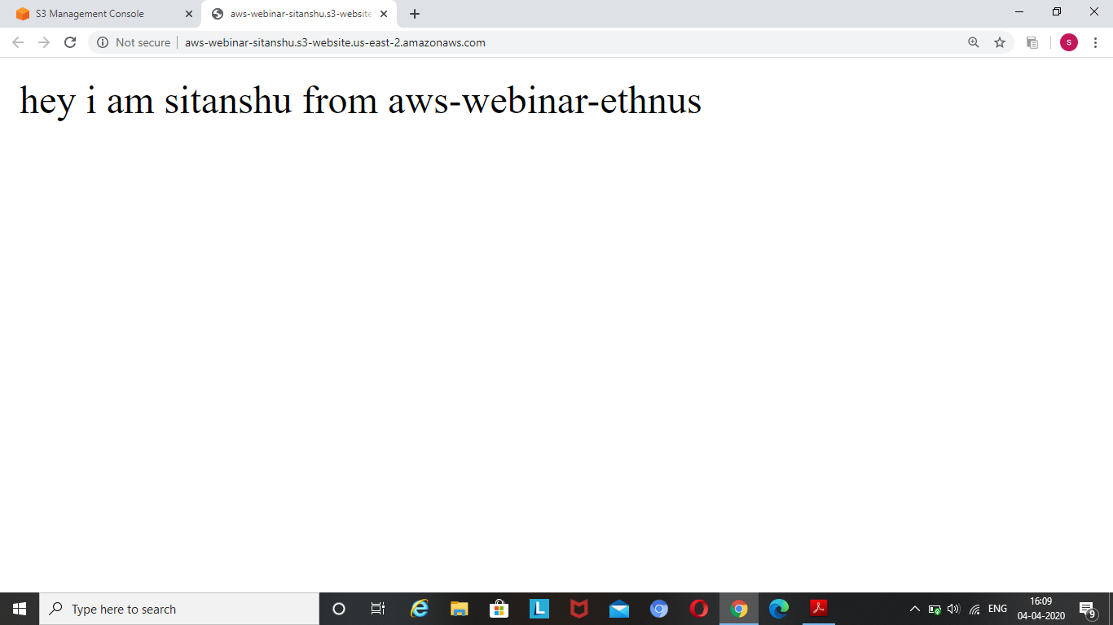

FACE DETECT

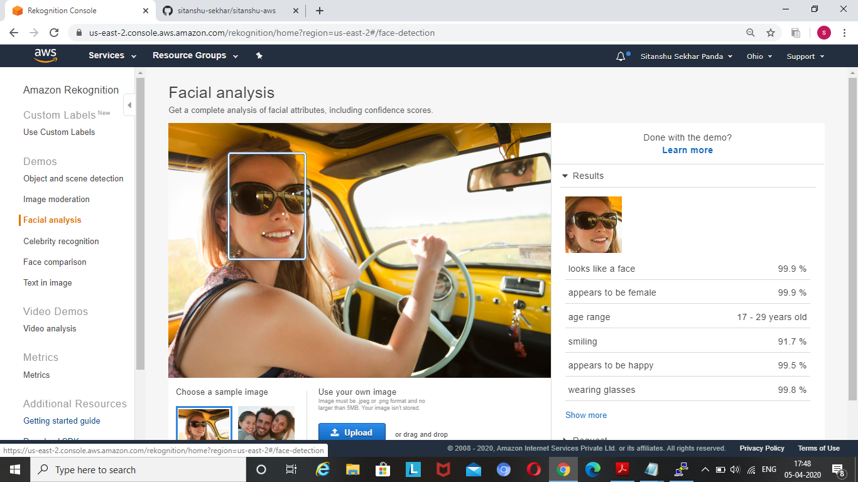

FACE COMPARE

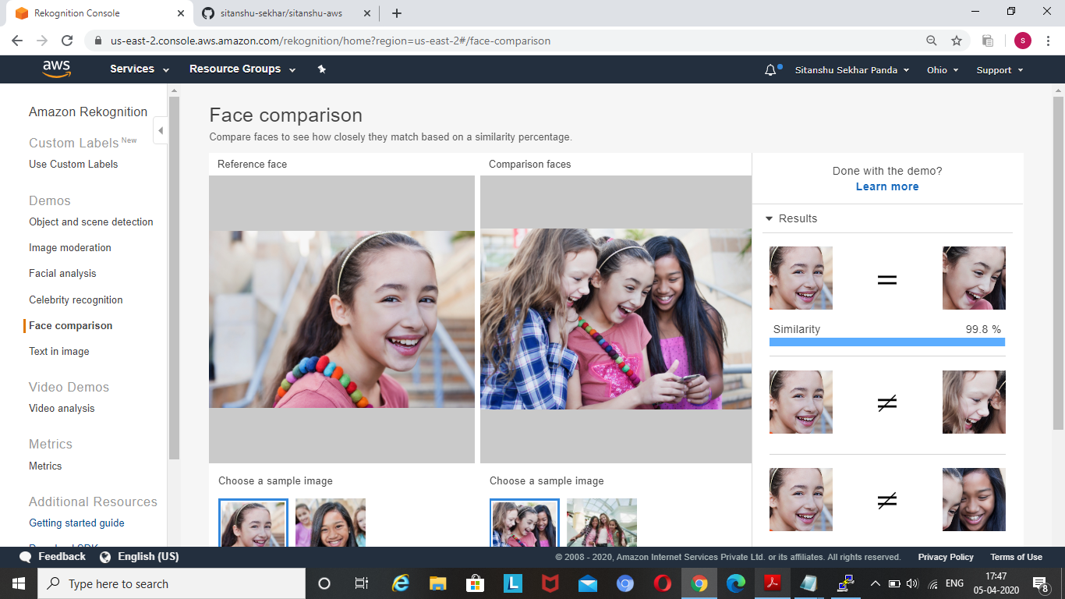

CELEBRITY REKOGNITION

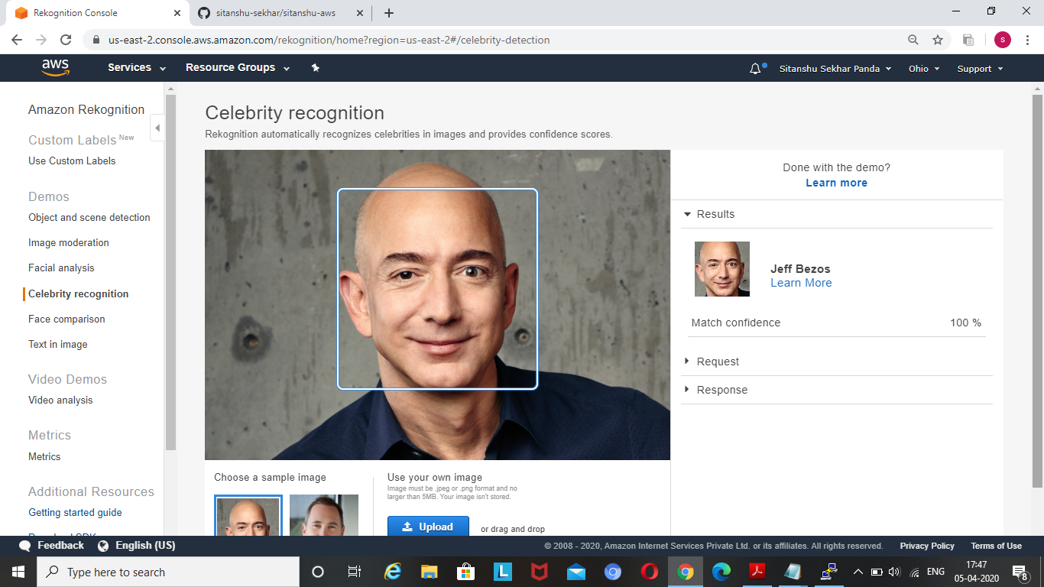

TEXT IN IMAGE

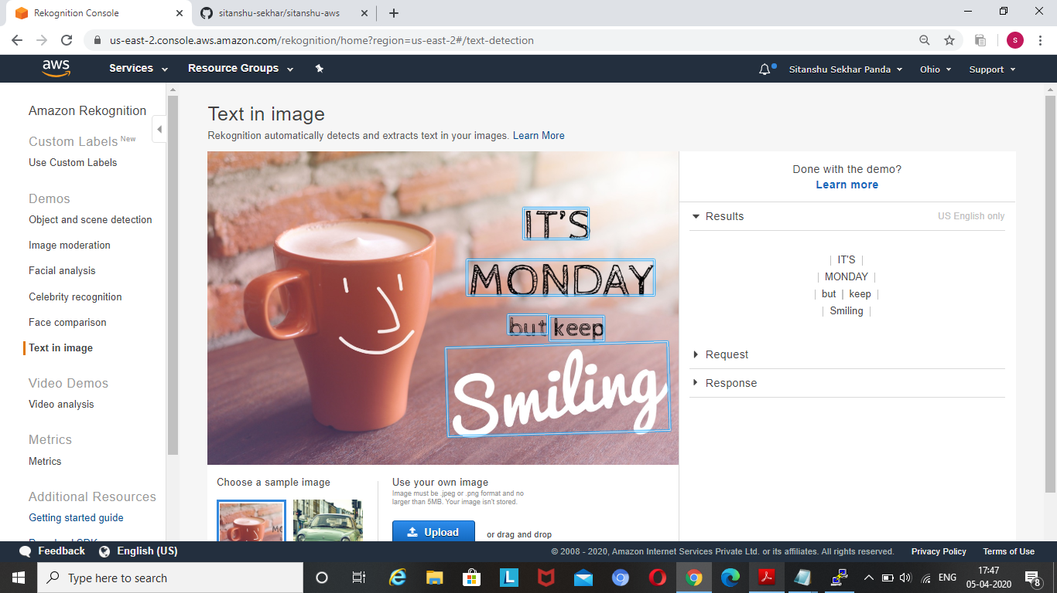

INSTALLING AWS SDK

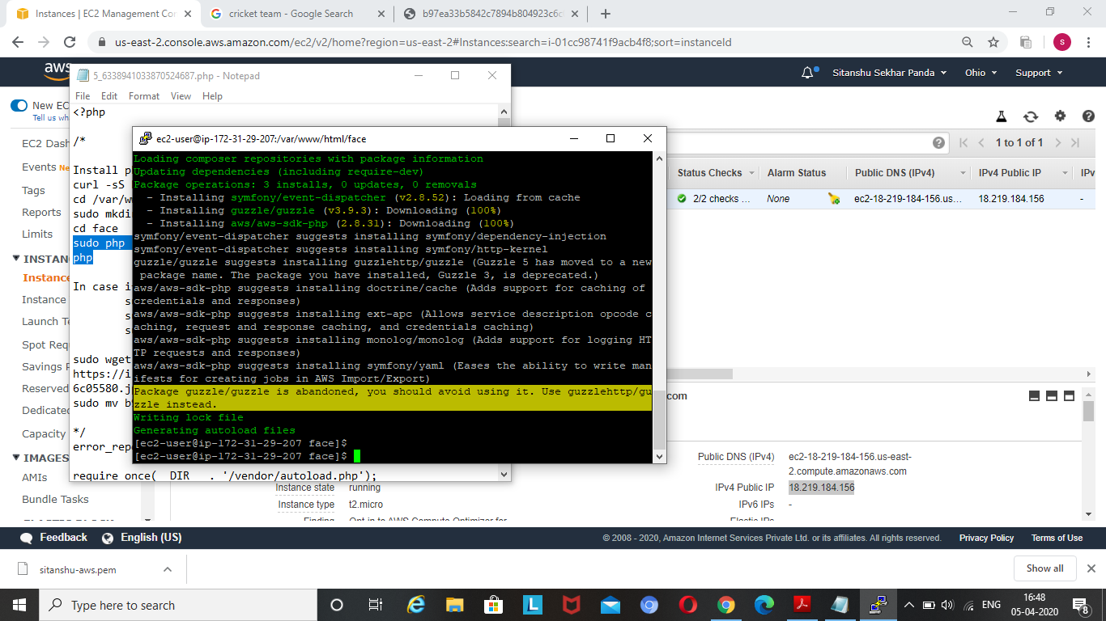

INSTALLING PHP

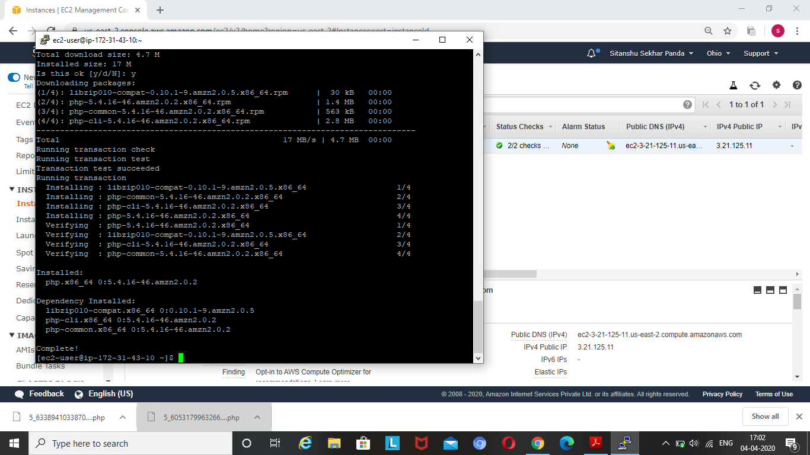

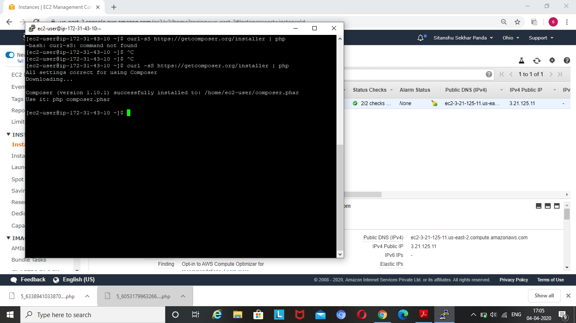

INDEX.PHP CODE

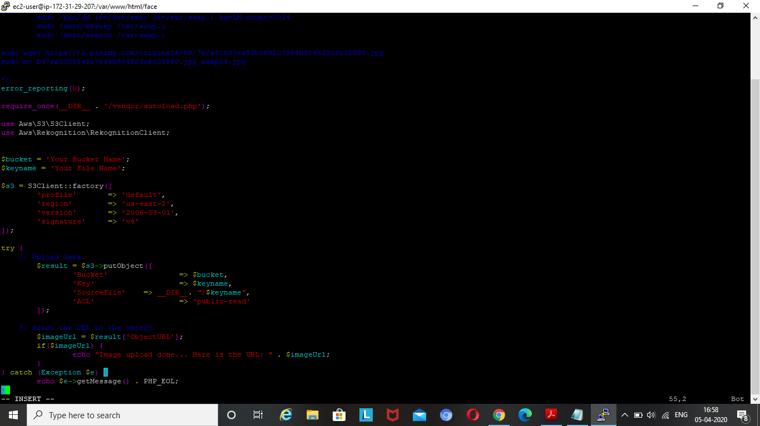

SUCCESS SCREENSHOT FOR UPLOAD

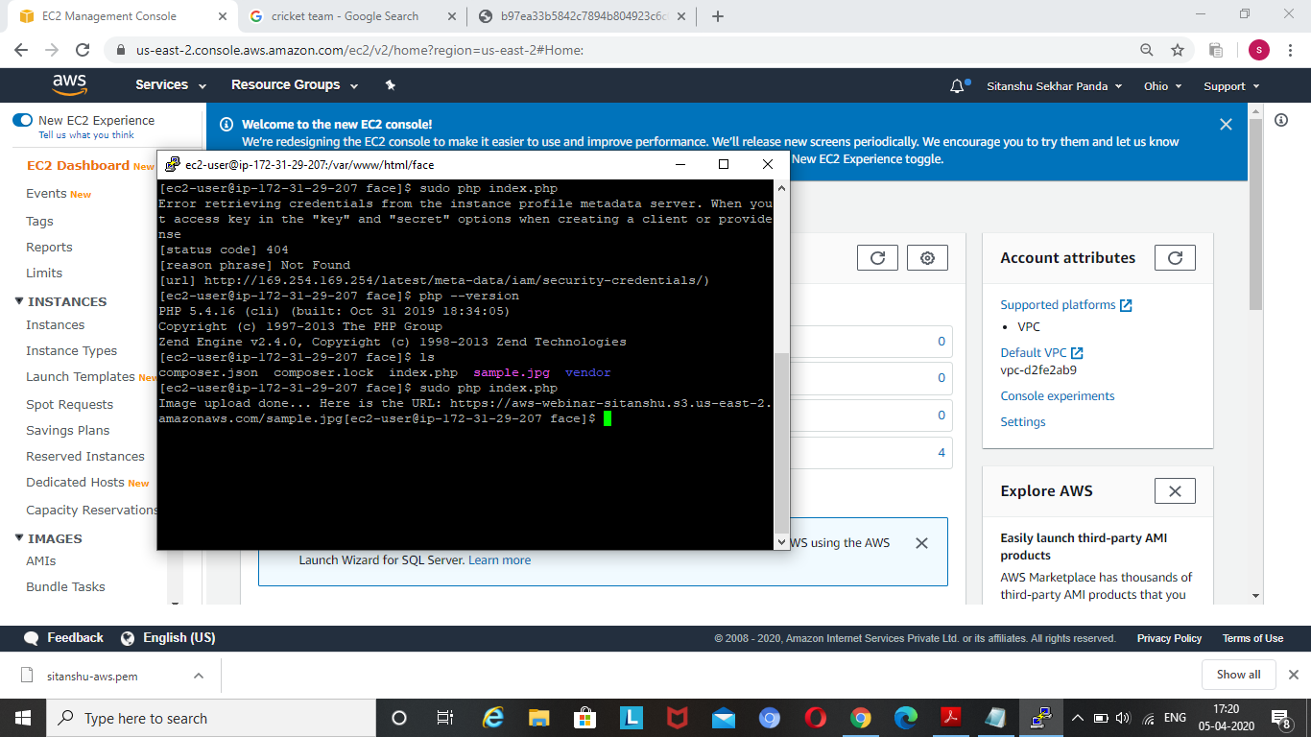

FACE DETECT

